Name: ______________________________ Date: __________ Period: ______ Number: _____

Things You Never Say To Your Dance Teacher

Read the article that is attached: rockett.es/2yiDEiN

Answer the following questions after you have read the article:

- Based off of the second thing to never say to your dance teacher, what are three things you can do so that you can avoid this question?

- Number 7 talks about other teachers that you may encounter. Why do you think this may be insulting to the teacher you are asking?

- What can you do to make something “easy for you”, more challenging for yourself?

- How can you avoid being too tired for your dance class? List 3 specific things:

A.

B.

C.

- Why does the article say that you should not ask for something specific to do in class?

- What are the steps you need to do when you are absent for dance class?

- Why is it important to never give up on yourself and keep trying even when things get hard?

7 THINGS YOU SHOULD NEVER SAY TO YOUR DANCE TEACHER
Radio City Rockettes

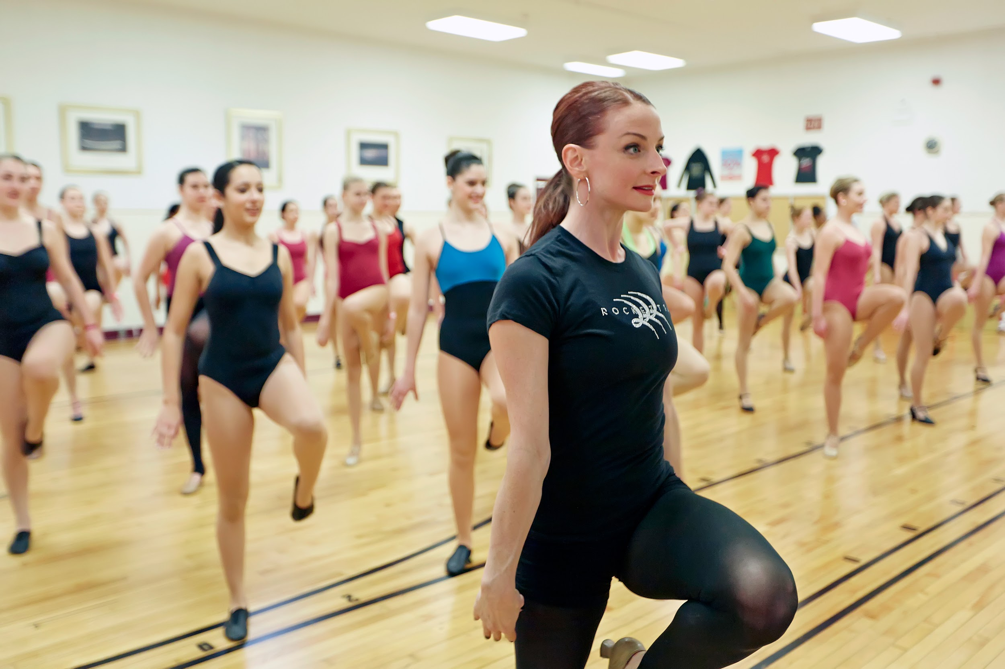
Good communication between dance student and teacher is a necessary part of dance training. There are, however, a few things that as a dance student, you should never say to your dance teacher. From “What time is it?” to “I’m too tired,” here are seven things your dance teacher isn’t a fan of hearing:
1. “Can we do ______ today?” This question (or its cousin, “Can you teach us this move?”) shows enthusiasm, which teachers do appreciate, but asking it can also indicate that you’re not interested in doing what the teacher has already thoughtfully planned for class. If you aren’t doing a particular move yet, your teacher probably has a reason.
2. “What time is it?” This question seems harmless enough when you’re out on the street, but in the dance studio … it is sure to lift your teacher’s eyebrow. By asking the time you are essentially wondering out loud, “How long until class is over?” The answer to that question is when the teacher says it’s over so, until then, don’t worry about it and keep your mind on dancing your best.
3. “This is too easy for me.” Advanced dancers give even the most basic movements, like plié or tendu, their full attention and best effort every time. They always challenge themselves to do better. If you really are doing this (be honest with yourself), talk with your teacher about taking a higher level class in additionto your own. Otherwise, don’t even think the words “too easy.”
4. “This is too hard for me.” Your teacher wouldn’t give you the material if she didn’t think you could master it eventually. Saying that something is too hard shows that you’re too afraid to try or that you just don’t want to. Either way, if you say you can’t, you won’t.
5. “Did I miss anything last time?” If you weren’t in class, of course you missed things. Probably lots of things and by the time you attend the next class, it’s too late to find out about them.
6. “I’m too tired.” Tired or not, saying so shows lack of motivation and that you’ve given up. It also shows disrespect for your teacher and the other dancers who are giving it their all despite being tired, hungry, thirsty … the point is, you’re making excuses and asking others to excuse less than your best.
7. “But my other teacher says ______.” Dance terminology and the way things are practiced can be different depending on your location and your teacher’s method of training. Your other teacher may teach something differently but that matters and applies when you are in his or her class, not this one. If you are curious, do some research or ask if a step sometimes has a different name to avoid potentially insulting either dance teacher.

